

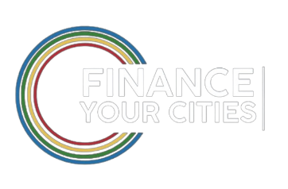
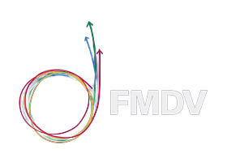

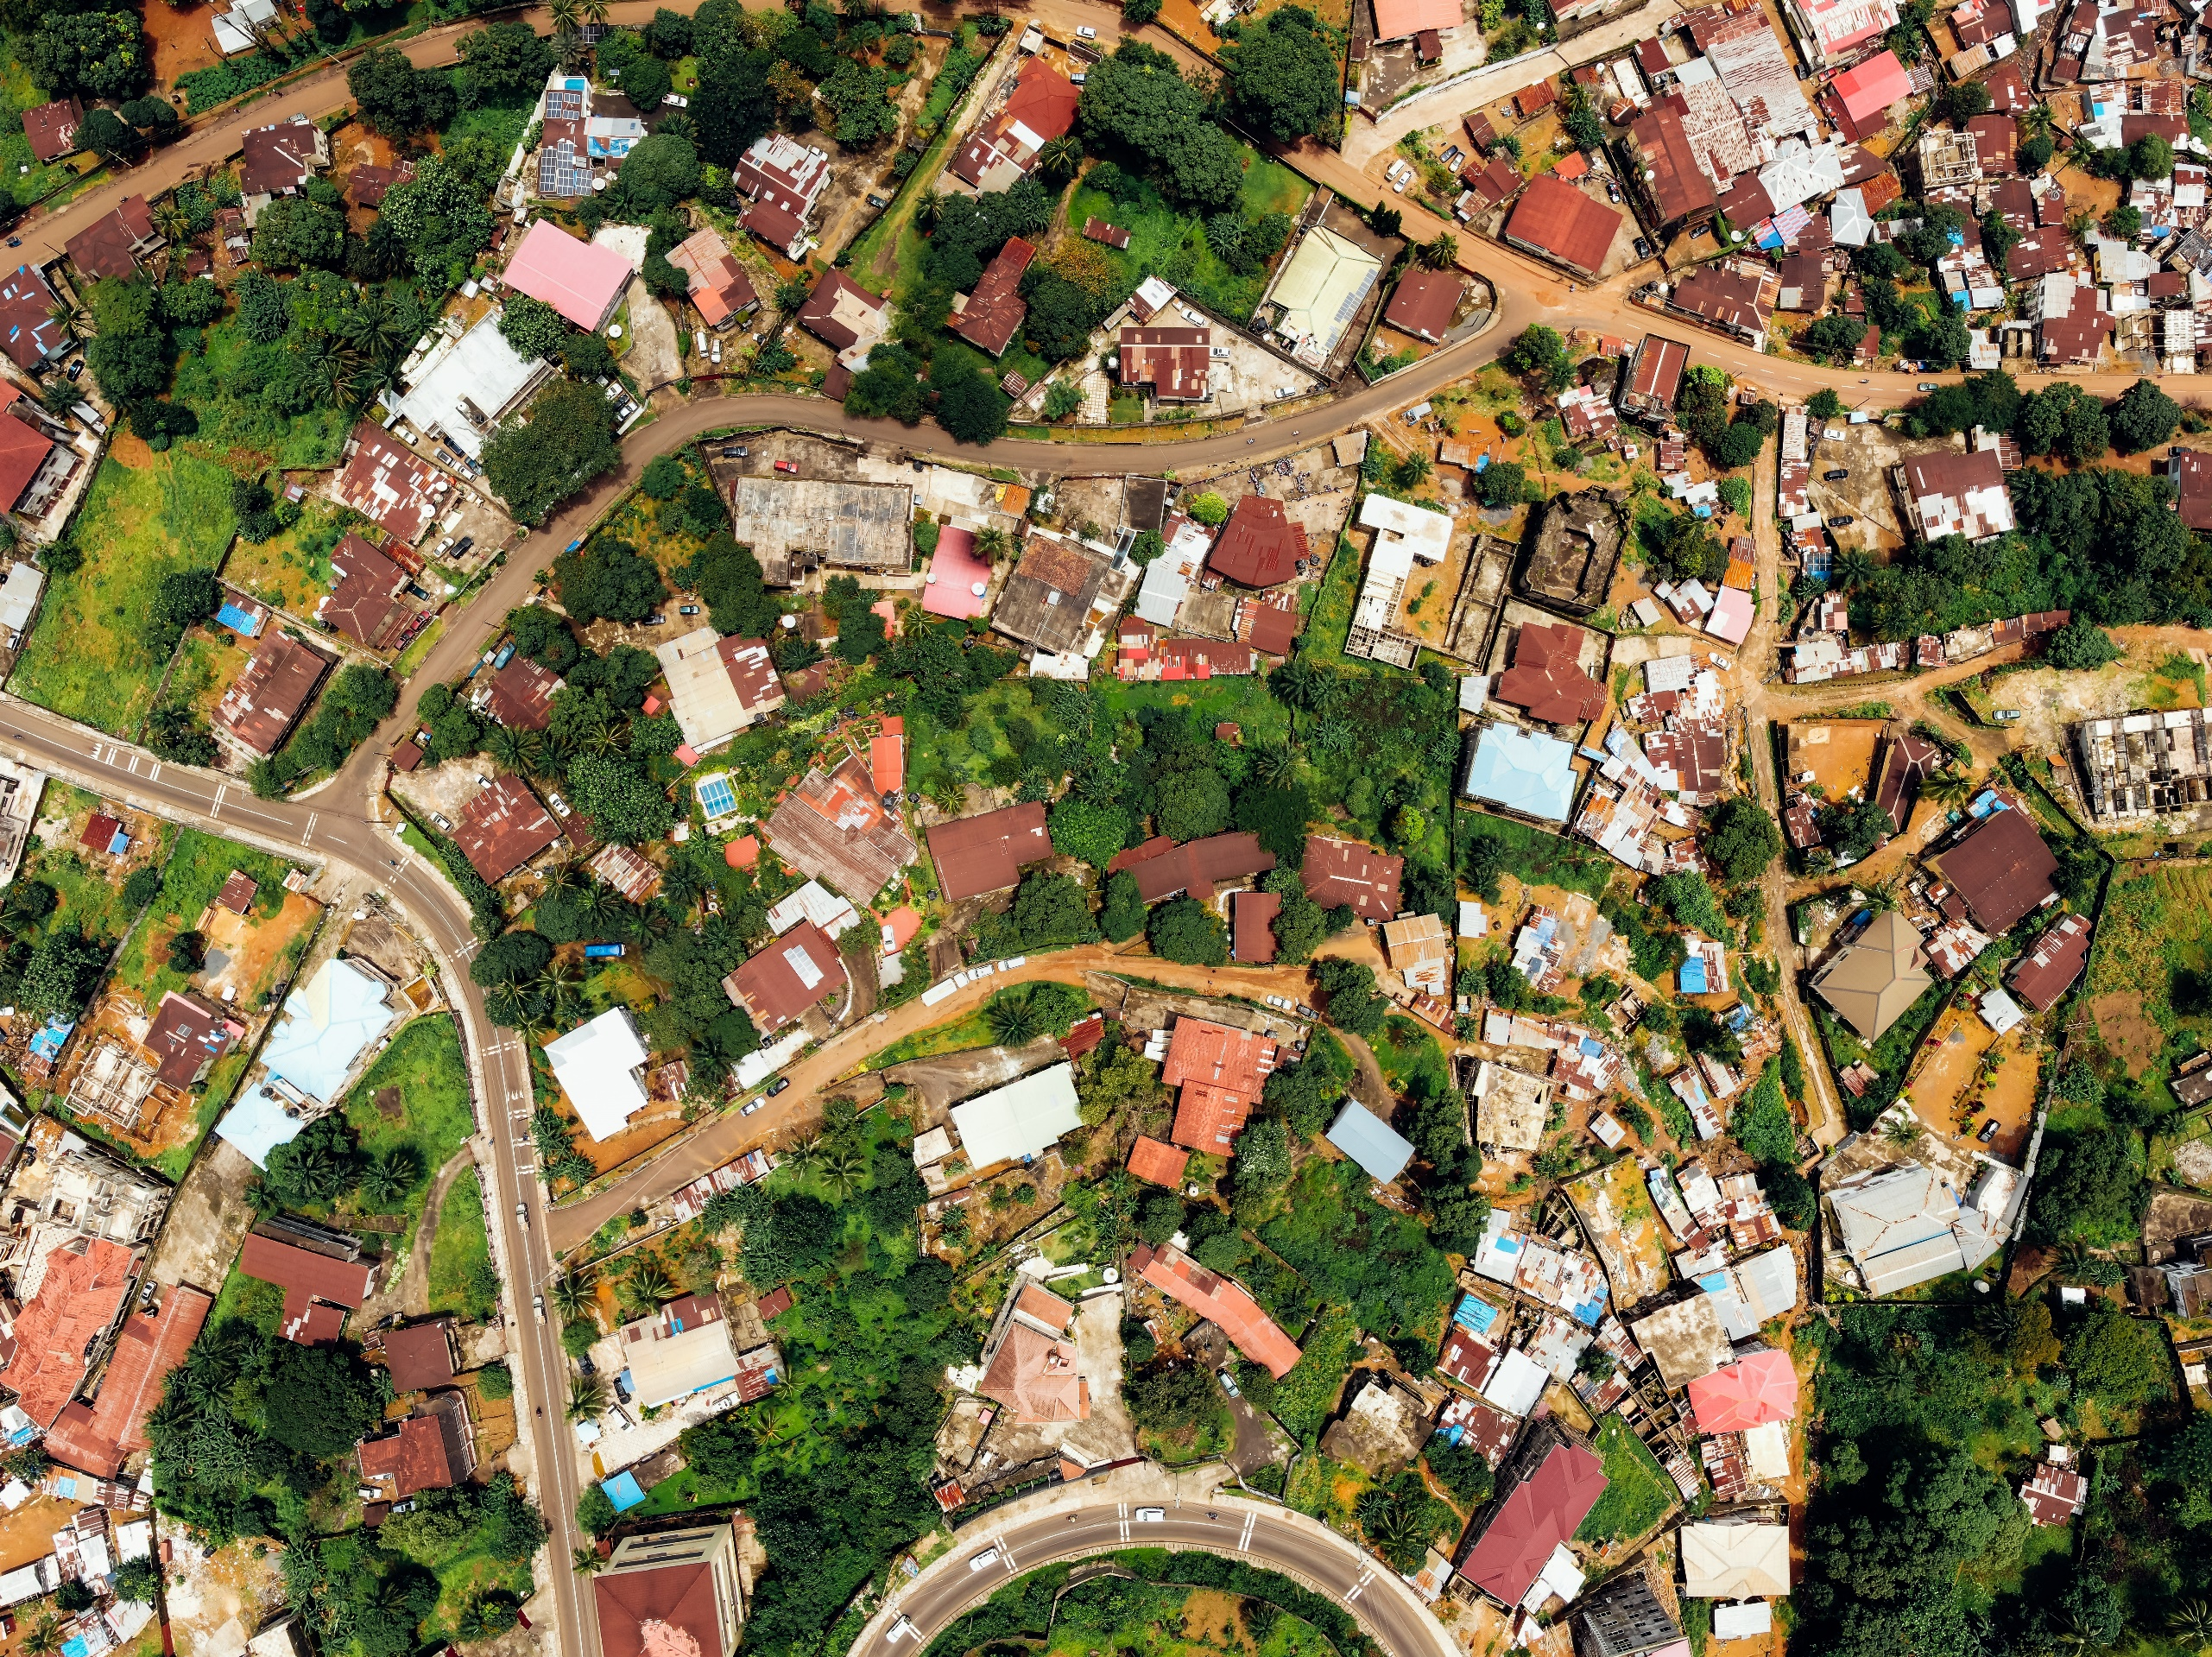
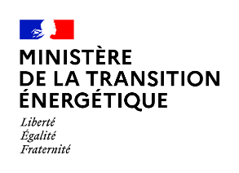
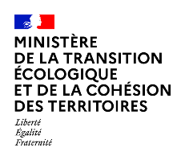



C
In partnership with
SUBMISSION
FORM

Finance Your Cities
Innovation Awards
Urban Climate Finance - 2024

Contact the Secretariat
Secretariat, FMDV / FYCInnovationAwards@fmdv.net
Fantin Ferreux, Program Officer, FMDV / fferreux@fmdv.net


General Introduction

The Innovation Awards identify, connect and promote financial innovations in favor of the sustainable, just and resilient transition and adaptation of cities and regions. The Innovation Awards appraise categories of players rather than specific sectors. The Finalists are institutions/actors that have designed and implemented innovative financial mechanisms, whether they are the main financial partner or the host institution.

Actors from the urban financing value chain who will be awarded (one per category) are:
- Local and Regional Governments,
- Ministries and National Agencies,
- Public Development Banks and Funds,
- A Jury’s special “Grand Prix”, all categories combined, will reward the most inspiring innovation to finance the urgent need for adaptation.

The award winners will benefit from exclusive visibility opportunities in international events and publications to showcase their inspiring model.
In addition to this “evidence-based advocacy”, Laureates will receive matchmaking support to replicate and/or upscale their innovation.
No cash prizes will be awarded to the winners.
The whole set of submitters will be gathered in a compendium serving as a resource for further exploration, and for identifying a Leaders League of urban finance innovators.

Entries

Please note that no entry fee is required.

By submitting your innovation to the Finance Your Cities Innovation Awards 2024 you warrant that your contribution is your own original work and can be shared with the partners of the Awards. No content will be shared with a general audience. If a third party owns the copyright of such works, you confirm that you have obtained their consent to our use and a waiver of their moral rights for these purposes. Any exception to these rules must be clearly identified when submitting the documents or communicated in advance to the Secretariat. The Secretariat will not share any content to third parties (e.g., journalists) without prior agreement with the focal point of each entry.

Judging Processes

Secretariat (FMDV) will provide technical support to the applicants and to a Technical Committee made of representatives from the partner organizations. It will also be responsible for an initial screening of applications prior to the assessment by the technical committee.

Technical Committee (FMDV and Partners) will conduct the technical review of the submissions and shortlist the Finalists. The chosen projects will then be pitched to the Jury who will deliberate and designate the Laureates.

Final judging for the Finance Your Cities Innovation Awards will be overseen by a representative panel of jurors selected for their knowledge, expertise, and commitment towards / in favor of financial innovation to trigger subnational climate action. The Jury’s decision on all shortlisted entries and laureates is final and no discussion regarding individual entries or award laureates will be undertaken.

The Innovation Awards international Jury is composed of 7 experts and structured as follows:
- 1 Representative of the French Ministry of Ecological transition and territorial cohesion,
- 1 Representative of ADEME,
- 1 Representative of a (non-UN) development finance institution,
- 1 Representative of a United Nations agency (or international civil society),
- 2 Representatives of FMDV and UCLG on behalf of local and regional government networks,
- 1 Expert from the private and banking sector.

What are we looking for?

Financial innovation can take many forms and serve many purposes. The innovation can:
- Be a new financing scheme, a new process of fiscal decentralization, a new financial incentive mechanism, or a new legal framework enhancing access to finance,
- Provide a new toolkit or approach to risk assessment,
- Make funds mobilization and payment solutions more accessible and predictable,
- Set up a new refinancing or repayment scheme,
- Provide new guarantees, counterparty de-risking, or a vehicle mobilizing specifically impact investors,
- Create meaningful channels to carbon finance,
- Bridge the gap to ‘small’ project size and pool resource to support limited technical with limited transaction costs,
- And many other solutions we have not heard of yet.

Eligibility of submitted projects

- Applicant organizations belong to one of the 5 categories. Submissions are exclusively applied to one category.
- All submissions must be either at the final stage of implementation or implemented in the last five years with evidence-based reporting material.
- All submissions will be considered for the Grand Prix dedicated to the specific issue of adaptation, when eligible. The recipient of the Grand Prix will not receive an award for the category it had originally entered.

Calendar

June – August 2024
Call for submissions
Support from the Secretariat

September 2024
Analysis of the Innovations & Shortlist by the Innovation Awards Technical Committee
Presentation of the Finalists to the Jury & Public Announcement

October 2024
Coaching of the Finalists by FMDV for pitching
Presentation of the Solutions to the Jury

November 2024
Innovation Awards Ceremony & Side-events during International High-Level Forums (WUF12, COP29)

December 2024 - November 2025
Promotion of the Winners during One Year

Basic Information

Focal Point
First Name: Click here to write your answer
Last Name: Click here to write your answer
Position: Click here to write your answer
City: Click here to write your answer
Country: Click here to write your answer
Applicant Email Address: Click here to write your answer
Applicant Telephone Number: Click here to write your answer

Organization Leading the Initative
Name of the Organization: Click here to write your answer
Type of Organization: Choose an answer
Social Medias of the Organization: Click here to write your answer

Name/Title of the Innovation
Click here to write your answer

Subtitle
Summarize the innovation in a few keywords

Website of the Organization
Preferably where the innovation is described

Team and Organization behind the Initiative
Please describe, in a few words, the organization and partners (if any) carrying the innovation (scope of action, number of employees)

Context

Country where your initiative is implemented
Briefly describe the main institutional arrangements for financing urban climate action in the country (main players, type of funds available and key modalities of access to the funding or financing opportunities). 300 words.

Urban areas where your initiative is implemented
Briefly describe the climate profile and priorities (mitigation, adaptation/resilience) of the cities where the innovation was piloted or implemented and tell us the main challenges your community/beneficiary needed the financial innovation for. 200 words.

What does your financial innovation do
Describe the specific barriers/obstacles you wanted to address/overcome, and the specific outcomes and results you have achieved through the innovation. Please keep in mind you will go into details on the financial model afterwards. 200 words.

What is your organization’s role in this innovation model
50 words.

Timeline
Please briefly draw the timeline of the innovation from inception to current stage. It is necessary to explain if the design and arrangements are completed and the innovation is running, or if it still in progress.

Partners of the initiative
Describe how partners have come to work together, the role they play, and how this collaboration may foster institutional or urban financing sector-specific change. The innovation responds to identified barriers in the urban climate project financing cycle. Through the initiative, partners have effectively addressed barriers such as (not exclusively): insufficient project size, limited technical capacity, counterparty risk, climate risk, administrative risk, regulatory risk, limited technology capacity, technology risk, refinancing risk, etc. 200 words.

Recommendations letters
When possible, please provide a recommendation letter or any statement or testimonial from the main partners who can confirm the strategic importance and impact of the initiative.

Innovation

Describe your ambition and commitment to support the locally implement the national sustainable or low-carbon urban development strategy. How does it related to the Global Agendas (Paris Agreement, 2030 Agenda, New Urban Agenda)
Be specific in terms of your Theory of change – the specific barriers you aimed to address and how you sought transformative changes through the outcomes you have achieved- and how the key performance indicators make a clear contribution to the nationally determined contributions and international Sustainable Development Goals targets. 200 words.

What transformative change did you devise and implement
Please briefly demonstrate how your innovation addresses context-specific barriers in a unique way that makes it different from existing solutions in your context. We suggest being specific in terms of the roles of the other organizations that have contributed to the success of the innovation. We also recommend describing how the innovation contributes (principle of additionality) to financially enabling urban climate action and cities ecological transition. 200 words.

Who or which other initiative has inspired you to design your innovation, if any
Please indicate specific references (publication, website, partner, etc.) if available.

Means of achieving behavioral change
Is there a specific allocation of resources to internal institutional development or technical assistance to the beneficiaries? How to you contribute to enrooting sustainable change and boost the urban climate finance market, trainings on the specifics of urban climate projects financing, or how to make sure financing arrangements do no harm or contribute to climate adaptation by improving land use, forestry and water resource management. 100 words.

How does the innovation intend to improve access and accessibility of your community/clients/beneficiaries to your urban climate finance resources, and build additional autonomy for your community/client/beneficiary
For instance, through technical assistance to the project sponsor (e.g., on the diversity of resources, financial engineering solutions or through digital solutions when relevant). 100 words.

Financial Aspects

Describe more specifically your urban climate financing model/mechanism:
1/ Provide information about the management and team profiling, as well as about the governance arrangements settings
200 words.
2/ Is there a specific institutional and legal/regulatory framework you fall under
Were any policy/regulatory reforms necessary; new rules of business or any relevant statutory change for your innovation to be implemented? 300 words.
3/ Provide information about the type of funding and financing products and services provided, the sourcing of your capital, the access criteria the control and transparency proceedings, the guarantees, the existing track record, etc.
Describe how you’re funding and financing products and source of financing are traceable and follow criteria to contribute to urban climate adaptation? 300 words.
4/ How does the innovation secure its financial viability over different cycles, if applicable?
Be specific regarding the economic viability and strategies regarding taxation, ring fenced local revenues, refinancing, new guarantees, reduced transaction costs, etc.) 200 words.

How does the innovation through its financing mechanism/process incentivize the climate component integration in the urban development and transition projects submitted? How do you support the clear objective of moving away from the "business as usual" scenario in the urban finance sector
Describe how the financial and technical services offered support meaningful and fruitful investments towards ecological transition in their urban territory (when possible, be specific in terms of land-uses/resource management). If relevant, describe your method to take into consideration transaction cost for climate informed urban transition projects. 200 words.

Has this financial innovation had to adapt to an external shock? If not, what is the resiliency of the model to absorb external shocks such as the ones resulting from unforeseen weather episodes, prolonged and multi-dimensional crises etc.
100 words.

How does the financial innovation incorporate and address a variety of funding needs – demand side (e.g., accessibility, answering the requirements, subsidies, financial engineering capacities, guarantees, etc.)
50 words.

How does the financial innovation incorporate and address a variety of financing requirements – supply side (e.g., scale of projects, perceived creditworthiness of the sponsor, debt repayment solutions, guarantees)
50 words.

Does the innovation have a specific action regarding urban adaptation financing
Describe any specific products and services, or specific financial modelling, etc.) linked to urban climate adaptation. How does the financial modeling include the "cost of inaction", ‘additional’ costs and the ‘’leave no one behind principle (multiplier effect) 300 words.

How does the financial model innovate in enforcing transparency and traceability rules and in incorporating climate justice provisions such as:
1/ Procurement rules that ensure the project ‘does no harm’ to land uses and resource management (i.e. water resources, forests, and minerals)
100 words.
2/ Procurement rules that ensure equitable participation of local stakeholders (local products, job creation, etc.)
Be specific if the mechanism incentives decent job opportunities for any vulnerable group. 100 words.

Impacts

Looking back at the original drive behind this initiative, how has the implementation process changed the mindset among the partners and beneficiaries? What are the “transformative” results you achieved
Please include qualitative and quantitative evidence on the number of projects financed/ the volume of funds mobilized/ the policies/legislation/planning/budgets/monitoring procedures that have made a tangible shift towards accelerating the pace to achieve low carbon/net-zero urban development and transition.

What made it work and what gives it the potential to be scaled up and replicated? Is it being scaled up or replicated elsewhere?
300 words.

Did you integrate a specific process of monitoring the climate impacts of the urban development and transition projects your innovation has supported
Describe the process in place and comment on the impacts measured, and more specifically on adaptation.

Provide evidence if the climate-focused approach of the financing mechanism has had impact on investment risk perception for urban climate projects
300 words.

